Digital Delivery External API Service
Personal Lines
Document Version 9.0

Table of Contents
1 Overview 3
2 Business Purpose 3
3 Architecture 3
3.1 Service Topology Diagram 3
4 Security 4
5 Digital Delivery Quote API 4
5.1 Request Message 4
5.2 Request Validation 10
5.3 Response Message 10
6 Digital Delivery BIND API 19
6.1 Request Message 19
6.2 Request Validation 22
6.3 Response Message 22
7 Exception Handling and Recovery 25
8 How to Test 30
9 Document Revision History 34

Overview
Hartford Steam Boiler (HSB) is constantly expanding its portfolio of system to system integration options via APIs hosted on Microsoft’s Azure Cloud.

Business Purpose
HSB reinsurance treaties are typically implemented and maintained in full by our clients. The client’s Quote, Issuance, and Policy Admin systems must be programmed to support the HSB products, and adopting changes to those products is the responsibility of the client. Clients may spend more than a year to plan and implement a new HSB product, and eventual changes to the product can present significant IT expense to adopt. This is particularly burdensome when new HSB products are evolving quickly to meet market demands. The purpose of the HSB Digital Delivery platform is to reduce the burden on client companies to deploy and maintain HSB products.
- The Digital Delivery Quote API will respond with the client company’s filed product limits, rates, deductibles, eligibility rules and form numbers.
- The Digital Delivery Bind API will respond with the client company’s filed forms and declaration pages, complete with selected product options.

Architecture
HSB has built a secured cloud Application Program Interface (API) to provide information related to Digital Delivery.
API’s are available through Secure Cloud with various security options, see section 4 for information.

Service Topology Diagram

Security
Access to HSB’s API products begins by obtaining a subscription account, and then enable your API module for that account. An API account can be coordinated through HSB’s integration team:
HSBIntegrationTeam@hsb.com
HSB utilizes Microsoft Azure’s API Management tool for exposing internal APIs to external Client Companies by applying two security/authentications to the HSB API (internal) and access the API from the Internet (external):
Security Level 1: URL and HSB provided Subscription Key,
Security Level 2: URL and HSB provided Subscription Key plus OAuth2 Token/certificate.

Digital Delivery Quote API
This service allows an external system to create Quote.

Request Message

Type | SubType | Field | Required for API | Required for Reporting | Description
SignonRq | SignonTransport/CustId | SPName | Y |  | Domain name of carrier
SignonRq | SignonTransport/CustId | CustLoginId | Y | Y | Identity of carrier - parent company
SignonRq | ----------- | ClientDt | Y |  | Date and time stamp from carrier's system
SignonRq | ----------- | CustLangPref | Y |  | Preferred language of requester
SignonRq | ClientApp | Org | Y |  | Name of requesting company
SignonRq | ClientApp | Name | Y |  | Insurer application name where request is originating from
SignonRq | ClientApp | Version | Y |  | Version of insurer application where request is originating from
InsuranceSvcRq | ItemIdInfo/OtherIdentifier | UID | Y |  | Unique identifier of the request.
PolicyRq | ----------- | BusinessPurposeTypeCd | Y | Y | This field identifies the type of transaction(NBQ,RWQ,PCQ,REW)
PolicyRq | ItemIdInfo/OtherIdentifier | UID | Y |  | Unique identifier of the request. It should be returned along with response to correlate. And should be on the Bind request as well to tie it back to the quote.
PolicyRq | ----------- | TransactionRequestDt | Y | Y | DateTime that carrier submits request to HSB
PolicyRq | ----------- | TransactionEffectiveDt | Y | Y | DateTime on which transaction takes effect  Mandatory in case of PCQ transaction
PolicyRq | ----------- | ACORDStandardVersionCd | Y |  | ACORD Version Number. Current version is 280 and It will support less than 280.
PolicyRq | Producer/ItemIdInfo | InsurerID |  |  | The agent ID an Insurer assigned to an individual Agent
PolicyRq | Producer | ContractNumber |  |  | Optional field for the agency/broker number or code assigned by the insurer
PolicyRq | Producer | PlacingOffice |  |  | Optional field for identifying the branch Id or code for the agency assigned by the insurer
PolicyRq | InsuredOrPrincipal | Name | Y | Y | Name of Insured Company or Person
PolicyRq | InsuredOrPrincipal/Addr | Addr1 | Y | Y | Mailing address of the Insured
PolicyRq | InsuredOrPrincipal/Addr | Addr2 |  |  | Mailing address of the Insured
PolicyRq | InsuredOrPrincipal/Addr | City | Y | Y | Mailing City of the insured
PolicyRq | InsuredOrPrincipal/Addr | StateProvCd | Y | Y | Mailing State of the insured
PolicyRq | InsuredOrPrincipal/Addr | PostalCode | Y | Y | Mailing postal code of insured
PolicyRq | InsuredOrPrincipal/ Communications | EmailAddr |  | Y | Mailing email address of insured
PolicyRq | InsuredOrPrincipal | Surname |  |  | Last Name of Insured Person
PolicyRq | InsuredOrPrincipal | GivenName |  |  | First Name of Insured Person
PolicyRq | InsuredOrPrincipal | OtherGivenName |  |  | Middle Name of Insured Person
PolicyRq | InsuredOrPrincipal | TitlePrefix |  |  | Title of Insured Person
PolicyRq | Policy | Policy Number | Y | Y | Policy number will be optional for New business and rewrite transaction and it will be mandatory for policy change and renewal transaction.
PolicyRq | Policy | LOBCd | Y | Y | Clients policy that we are attaching to(HOME and DFIRE)
PolicyRq | Policy | NAICCd | Y |  | NAIC code of the writing company
PolicyRq | Policy | ControllingStateProvCd | Y |  | Controlling state of the underlying policy to which HSB products may be attached.
PolicyRq | Policy/ContractTerm | EffectiveDt | Y |  | Effective date of underlying policy to which HSB products will be attached
PolicyRq | Policy/ContractTerm | ExpirationDt | Y | Y | Expiration date of underlying policy to which HSB products will be attached
PolicyRq | Policy/Form | FormNumber |  | Y | Homeowner Policy Form Number
PolicyRq | Policy/Form | FormName |  |  | Homeowner Policy Form Name
PolicyRq | Policy/Form | EditionDt |  | Y | Homeowner Policy Form Edition Date
PolicyRq | OtherOrPriorPolicy | PolicyCd |  |  | Code used to identify the type of policy being defined. In this case it is ‘Prior’
PolicyRq | OtherOrPriorPolicy | PolicyNumber |  | Y | Prior Policy Number for Rewrite transactions
PolicyRq | Policy/QuoteInfo | CompanysQuoteNumber |  |  | Carrier's quote number
PolicyRq | Policy | RenewalStatusCd |  |  | RenewalStatusCd is to identify the policy type for PCQ transaction whether NBS or RWL.  For new business will be blank, for renewal value equal to “Renewed”
PolicyRq | Policy | OriginalPolicyInceptionDt |  |  | The original home owner policy effective date
PolicyRq | Policy | TierCd |  |  | pricing category based upon underwriting criteria to distinguish base rates for the pricing segment
PolicyRq | Policy/Coverage | CoverageCd |  |  | Codes for the coverage provided(HSP,SRVLN,CLIAB)
PolicyRq | Policy/Coverage | EffectiveDt |  | Y  For PCQ and RWQ | Effective date of underlying policy to which HSB products will be attached.  Effective date will be mandatory in only PCQ transaction.
PolicyRq | Policy/PolicyExt | ApprovalNumber |  | Y | Provided by HSB during manual workflow- Format : ANPL123456
PolicyRq | Location | id | Y |  | Location Identifier
PolicyRq | Addr | Addr1 |  |  | Location Address
PolicyRq | Addr | City |  |  | Location City
PolicyRq | Addr | StateProvCd |  |  | Location State
PolicyRq | Addr | PostalCode |  |  | Location Postal Code
PolicyRq | Location | LocationName |  |  | Descriptive name of the locaiton
PolicyRq | Location | ReportingTransactionTypeCd |  |  | To notify the transaction on the location.  Valid values= AMENDMENT;CANCELLATION;ENDORSEMENT;NEW;REINSTATEMENT;RENEWAL;VOID
HomeLineBusiness | Dwell | LocationRef | Y |  | Location reference to attach the dwelling details to Location
HomeLineBusiness | Dwell/Construction | YearBuilt | Y | Y | Year in which the property was constructed
HomeLineBusiness | Dwell/Construction/BldgArea | NumUnits |  | Y | Total Living Area
HomeLineBusiness | Dwell/Construction/BldgArea | UnitMeasurementCd |  | Y | Represents measurement unit, sq feet
HomeLineBusiness | Dwell/Construction | NumUnits |  | Y | Number of Units in Dwelling
HomeLineBusiness | Dwell/Construction/DwellOccupancy | ResidenceTypeCd |  | Y | Code for Dwelling/Residence type provided APT=Apartment;CD=Condo;CO=Co-Op;DU=Duplex;DW=Dwelling-Insured Residence (non-farm);MH=Mobile Home;OTH=Other;RH=Row House;TH=Townhouse APT=Apartment;CD=Condo;CO=Co-Op;DU=Duplex;DW=Dwelling-Insured Residence (non-farm);MH=Mobile Home;OTH=Other;RH=Row House;TH=Townhouse
HomeLineBusiness | Dwell/Construction/DwellOccupancy | DwellUseCd |  | Y | use of the dwelling by the insured/applicant  1=Primary,(non-seasonal) 3=Secondary(non-seasonal) 4=Seasonal,(secondary) 6=Farm;7=Vacant;8=Occasionally Occupied;OT=Other
HomeLineBusiness | Dwell/Construction/DwellOccupancy | OccupancyTypeCd |  |  | code identifying how the structure is inhabited  A=Absentee Owner;COC=Course of Construction;OCC=Occupied;OT=Other;OWNER=Owner;OWNTEN=Owner andTenant;P=Partially Vacant;TENAN=Tenant;UNOCC=Unoccupied;VACAN=Vacant
HomeLineBusiness | Dwell/Construction/DwellOccupancy | NatureBusinessCd |  |  | code identifying the type of business in Home  HM= Homeoffice/business; leave blank if not a home business
HomeLineBusiness | Dwell/DwellRating | TerritoryCd |  |  | Geographic territory assignment at the policy level.
HomeLineBusiness | Dwell/BldgProtection | FireProtectionClassCd |  |  | Fire protection class for the locality where the dwelling is located
HomeLineBusiness | Dwell/BldgProtection/DistanceToHydrant | NumUnits |  |  | The distance to the nearest fire hydrant
HomeLineBusiness | Dwell/BldgProtection/DistanceToHydrant | UnitMeasurementCd |  |  | Distance in Feets
HomeLineBusiness | Dwell/BldgImprovements | HeatingImprovementYear |  |  | The year the heating venting air conditioning system was last updated
HomeLineBusiness | Dwell/BldgImprovements | PlumbingImprovementYear |  |  | The year plumbing improvements were made
HomeLineBusiness | Dwell/BldgImprovements | WiringImprovementYear |  |  | The year the wiring was last updated
HomeLineBusiness | Dwell/Coverage/Limit | FormatInteger | Y | Y | 3 Coverage A, B and C value.
HomeLineBusiness | Dwell/Coverage/Limit | LimitAppliesToCd | Y |  | Code to identify the coverage for A, B and C.  Cov A = Prop (Dwelling)  Cov B = OtherStructures  Cov C = Contents
HomeLineBusiness | Dwell/Deductible | FormatInteger |  | Y | Homeowner Policy Deductible Amount
HomeLineBusiness | Dwell/Deductible | DeductibleAppliesToCd |  |  | Deductible code to reflect whether this per occurrence based or Aggregate/Included
HomeLineBusiness | Dwell/DwellExt | InsuranceRiskScore |  |  | Policy level numeric risk score
HomeLineBusiness | Dwell/DwellExt/HoBasePremAmt | Amt |  | Y | Homeowner Base Premium Amount, excluding Credits and surcharges

Request Validation
Requests that do not contain elements marked as “Y” will generate a failure response from the API. See Section 7 for details regarding Exception Handling and Recovery.

Response Message

Type | Sub Type | Field | Description
SignonRs | Status | StatusCd | Status of transaction
SignonRs | Status | StatusDesc | Description of transaction status
SignonRs | CustId | SPName | Domain name of carrier
SignonRs | CustId | CustLoginId | Identity of carrier - parent company
SignonRs | ----------- | ClientDt | Date and time stamp from carrier's system
SignonRs | ----------- | CustLangPref | Preferred language of requester
SignonRs | ClientApp | Org | Name of requesting company
SignonRs | ClientApp | Name | Application being requested
SignonRs | ClientApp | Version | Application Version
SignonRs | ----------- | ServerDt | Date and time stamp from HSB's system
SignonRs | ----------- | Language | Language of the HSB response
InsuranceSvcRs | ItemIdInfo | UID | Unique identifier of the request or response.
InsuranceSvcRs | PolicyRs | BusinessPurposeTypeCd | This field identifies the type of transaction
InsuranceSvcRs | PolicyRs /OtherIdentifier | UID | Unique identifier of the request. It should be returned along with response to correlate.
InsuranceSvcRs | PolicyRs | TransactionResponseDt | Date that HSB Responds to the carrier's request
InsuranceSvcRs | PolicyRs | TransactionEffectiveDt | Date on which the transaction takes effect
InsuranceSvcRs | PolicyRs/ MsgStatus | MsgStatusCd | HSB sends in response, valid values - Success, Error, SuccessWithInfo
InsuranceSvcRs | PolicyRs/ MsgStatus | MsgErrorCd | HSB response when MsgStatusCd is ‘Error’. valid values are DataError, GeneralFailure, NotAvailable
InsuranceSvcRs | PolicyRs/MsgStatus/ ExtendedStatus | ExtendedStatusCd | HSB sends in response when an error or informational message is to be conveyed to the insurer. Applies when MsgStatusCd = ‘SuccessWithInfo’ or (‘Error’ and MsgErrorCd = ‘DataError’). Valid values = ‘DataMissing’, ‘DataInvalid’, ‘DataNotFound’.
InsuranceSvcRs | PolicyRs/MsgStatus/ ExtendedStatus | ExtendedStatusDesc | HSB sends in response when an error or informational message is to be conveyed to the insurer. Applies when MsgStatusCd = ‘SuccessWithInfo’ or (‘Error’ and MsgErrorCd = ‘DataError’). Valid values = ‘DataMissing’, ‘DataInvalid’, ‘DataNotFound’.
InsuranceSvcRs | PolicyRs | ACORDStandardVersionCd | ACORD Version Number
InsuranceSvcRs | PolicyRs/ Producer/ ItemIdInfo | InsuredID | This agent ID an Insurer assigned to an individual Agent
InsuranceSvcRs | PolicyRs/ Producer | ContractNumber | Optional field for the agency/broker number or code assigned by the insurer
InsuranceSvcRs | PolicyRs/ Producer | PlacingOffice | Optional field for identifying the branch Id or code for the agency assigned by the insurer
InsuranceSvcRs | PolicyRs/InsuredOrPrincipal | Name | Name of Insured Company or Person
InsuranceSvcRs | PolicyRs/InsuredOrPrincipal/Addr | Addr1 | Mailing address of the Insured
InsuranceSvcRs | PolicyRs/InsuredOrPrincipal/Addr | Addr2 | Mailing address of the Insured
InsuranceSvcRs | PolicyRs/InsuredOrPrincipal/Addr | City | Mailing City of the insured
InsuranceSvcRs | PolicyRs/InsuredOrPrincipal/Addr | StateProvCd | Mailing State of the insured
InsuranceSvcRs | PolicyRs/InsuredOrPrincipal/Addr | PostalCode | Mailing postal code of insured
InsuranceSvcRs | PolicyRs/InsuredOrPrincipal/ Communications | EmailAddr | Mailing email address of insured
InsuranceSvcRs | PolicyRs/InsuredOrPrincipal | Surname | Last Name of Insured Person
InsuranceSvcRs | PolicyRs/InsuredOrPrincipal | GivenName | First Name of Insured Person
InsuranceSvcRs | PolicyRs/InsuredOrPrincipal | OtherGivenName | Middle Name of Insured Person
InsuranceSvcRs | PolicyRs/InsuredOrPrincipal | TitlePrefix | Title of Insured Person
InsuranceSvcRs | PolicyRs/Policy | Policy Number | Policy number will be optional for New business and rewrite transaction and it will be mandatory for policy change and renewal transaction.
InsuranceSvcRs | PolicyRs/Policy | LOBCd | Clients policy that we are attaching to(HOME and DFIRE)
InsuranceSvcRs | PolicyRs/Policy | NAICCd | NAIC code of the writing company
InsuranceSvcRs | PolicyRs/Policy | ControllingStateProvCd | Controlling state of the underlying policy to which HSB products may be attached.
InsuranceSvcRs | PolicyRs/Policy/ContractTerm | EffectiveDt | Effective date of underlying policy to which HSB products will be attached
InsuranceSvcRs | PolicyRs/Policy/ContractTerm | ExpirationDt | Expiration date of underlying policy to which HSB products will be attached
InsuranceSvcRs | PolicyRs/Policy/Form | FormNumber | Homeowner Policy Form Number
InsuranceSvcRs | PolicyRs/Policy/Form | FormName | Homeowner Policy Form Name
InsuranceSvcRs | PolicyRs/Policy/Form | EditionDt | Homeowner Policy Form Edition Date
InsuranceSvcRs | PolicyRs/OtherOrPriorPolicy | PolicyCd | Code used to identify the type of policy being defined. In this case it is ‘Prior’
InsuranceSvcRs | PolicyRs/OtherOrPriorPolicy | PolicyNumber | Prior Policy Number for Rewrite transactions
InsuranceSvcRs | PolicyRs/Policy/QuoteInfo | CompanysQuoteNumber | Carrier's quote number
InsuranceSvcRs | PolicyRs/Policy | RenewalStatusCd | RenewalStatusCd is to identify the policy type for PCQ transaction whether NBS or RWL.  For new business will be blank, for renewal value equal to “Renewed”
InsuranceSvcRs | PolicyRs/Policy | OriginalPolicyInceptionDt | The original home owner policy effective date
InsuranceSvcRs | PolicyRs/Policy | TierCd | pricing category based upon underwriting criteria to distinguish base rates for the pricing segment
InsuranceSvcRs | PolicyRs/Policy/Coverage | CoverageCd | Codes for the coverage provided( HSP, SRVLN, CLIAB)
InsuranceSvcRs | PolicyRs/Policy/Coverage | EffectiveDt | Effective date of underlying policy to which HSB products will be attached.  Effective date will be mandatory in only PCQ transaction.
InsuranceSvcRs | PolicyRs/Policy/ /CoverageAvailable/ItemIdInfo | VersionNumber | Informs the carrier the version of the Product HSB is using within this request for rate/quote. The version number will align with the version that carrier has adopted – based on rate/rule filings.
InsuranceSvcRs | PolicyRs/Policy/ /CoverageAvailable | CoverageCd | Code of the HSB coverage provided
InsuranceSvcRs | PolicyRs/Policy/ /CoverageAvailable | CoverageDesc | Description of available coverage
InsuranceSvcRs | PolicyRs/Policy/ /CoverageAvailable | CoverageName | Name of the coverage
InsuranceSvcRs | PolicyRs/Policy/ /CoverageAvailable/ Deductible | FormatInteger | Deductible for the available coverage
InsuranceSvcRs | PolicyRs/Policy/ /CoverageAvailable/ Deductible | DeductibleTypeCd | Notifies the deductible is for which coverage – Cov A, B or C.
InsuranceSvcRs | PolicyRs/Policy/ /CoverageAvailable/ Deductible | DeductibleAppliesToCd | Deductible code to reflect whether this per occurrence based or Included
InsuranceSvcRs | PolicyRs/Policy/ /CoverageAvailable/ CurrentTermAmt | Amt | Gross Premium for HSB Coverage Option
InsuranceSvcRs | PolicyRs/Policy/ /CoverageAvailable/ Form | FormNumber | Form Number to be part of response, will driven based on the state
InsuranceSvcRs | PolicyRs/Policy/ /CoverageAvailable/ Form | FormName | Form name
InsuranceSvcRs | PolicyRs/Policy/ /CoverageAvailable/ Form | EditionDt | The date usually found on the preprinted form, which indicates the date the form became effective.
InsuranceSvcRs | PolicyRs/Policy/ /CoverageAvailable/CoverageSupplement | CoverageSubCd | Coverage code of supplemental coverage available with this product
InsuranceSvcRs | PolicyRs/Policy/ /CoverageAvailable /CoverageSupplement | CoverageDesc | Description of supplemental coverage
InsuranceSvcRs | PolicyRs/Policy/ /CoverageAvailable/CoverageSupplement | CoverageName | Name of supplemental coverage
InsuranceSvcRs | PolicyRs/Policy/ /CoverageAvailable/CoverageSupplement | SubjectOptionsTitleCd | This code whether the coverage is a first party or third party coverage. Valid values - FUL1P or FUL3P
InsuranceSvcRs | PolicyRs/Policy/ /CoverageAvailable/CoverageSupplement/CoverageSupplementExt/ Limit | FormatInteger | Product Limit
InsuranceSvcRs | PolicyRs/Policy/ /CoverageAvailable/CoverageSupplement/CoverageSupplementExt/ Limit | LimitAppliesToCd | Code to signify whether the Limit is Per occurrence based or Aggregate.
InsuranceSvcRs | PolicyRs/Policy/ /CoverageAvailable/CoverageSupplementExt/ NetPremiumPaidAmt | Amt | Net Premium for the coverage
InsuranceSvcRs | PolicyRs/Policy/ /CoverageAvailable/CoverageSupplementExt/ Limit | FormatText or FormatInteger | Sublimit of the coverage
InsuranceSvcRs | PolicyRs/Policy/ /CoverageAvailable/CoverageSupplementExt/ Limit | LimitAppliesToCd | Limit code to show whether it is per occurrence or Aggregate
InsuranceSvcRs | PolicyRs/Policy/ /CoverageAvailable/CoverageSupplement/ QuestionAnswer | QuestionCd | Code identifying eligibility requirement
InsuranceSvcRs | PolicyRs/Policy/ /CoverageAvailable/CoverageSupplement/ QuestionAnswer | AnswerTypeCd | Acceptable code for the answer. Y/N radio button
InsuranceSvcRs | PolicyRs/Policy/ /CoverageAvailable/CoverageSupplement/ QuestionAnswer | QuestionText | Text associated with the eligibility requirement
InsuranceSvcRs | PolicyRs/Policy/ /CoverageAvailable/CoverageSupplement/QuestionAnswer/QuestionAnswerExt | AcceptabilityAnswer | The answer accepted for the eligibility question to approve the request.
InsuranceSvcRs | PolicyRs/Policy/ /CoverageAvailable/CoverageSupplement/QuestionAnswer/CoverageSupplementExt | CoverageSupplementAppliesToCd | To reflect whether this is eligibility question code or any other reason code
InsuranceSvcRs | PolicyRs/Policy/ /CoverageAvailable/CoverageSupplement/QuestionAnswer/CoverageSupplementExt | MinNumQuestionsMatchAcceptability | The minimum number of valid answers to make the request eligible for quote
InsuranceSvcRs | PolicyRs/Policy/ /CoverageAvailable | CompanyProductCd | Code for the product offered by HSB
InsuranceSvcRs | PolicyRs/PolicyExt/ | ApprovalNumber | Provided by HSB during manual workflow- Format : ANPL123456
InsuranceSvcRs | PolicyRs/Location | id | Location Identifier
InsuranceSvcRs | PolicyRs/Location/Addr | Addr1 | Location Address
InsuranceSvcRs | PolicyRs/Location/Addr | City | Location City
InsuranceSvcRs | PolicyRs/Location/Addr | StateProvCd | Location State
InsuranceSvcRs | PolicyRs/Location/Addr | PostalCode | Location Postal Code
InsuranceSvcRs | PolicyRs/Location | LocationName | Descriptive name of the locaiton
InsuranceSvcRs | PolicyRs/Location | ReportingTransactionTypeCd | To notify the transaction on the location.  Valid values= AMENDMENT;CANCELLATION;ENDORSEMENT;NEW;REINSTATEMENT;RENEWAL;VOID
InsuranceSvcRs | HomeLineBusiness/Dwell | LocationRef | Location reference to attach the dwelling details to Location
InsuranceSvcRs | HomeLineBusiness/Dwell/ Construction | YearBuilt | Year in which the property was constructed
InsuranceSvcRs | HomeLineBusiness/Dwell/Construction/BldgArea | NumUnits | Total Living area
InsuranceSvcRs | HomeLineBusiness/Dwell/Construction/BldgArea | UnitMeasurementCd | Represents measurement unit, sq feet
InsuranceSvcRs | HomeLineBusiness/Dwell/Construction | NumUnits | Number of Units in Dwelling
InsuranceSvcRs | HomeLineBusiness/Dwell/Construction/ DwellOccupancy | ResidenceTypeCd | Code for Dwelling/Residence type provided  APT=Apartment  CD=Condo  CO=Co-Op  DU=Duplex  DW=Dwelling-Insured  Residence (non-farm)  MH=MobileHome  OTH=Other  RH=RowHouse  TH=Townhouse
InsuranceSvcRs | HomeLineBusiness/Dwell/Construction/DwellOccupancy | DwellUseCd | use of the dwelling by the insured/applicant  1=Primary,(non-seasonal)  3=Secondary(non-seasonal) 4=Seasonal,(secondary)  6=Farm  7=Vacant  8=Occasionally Occupied  OT=Other
InsuranceSvcRs | HomeLineBusiness/Dwell/Construction/DwellOccupancy | OccupancyTypeCd | code identifying how the structure is inhabited  A=Absentee  Owner  COC=Course of  Construction  OCC=Occupied  OT=Other  OWNER=Owner  OWNTEN=Owner andTenant;P=Partially Vacant  TENAN=Tenant  UNOCC=Unoccupied  VACAN=Vacant
InsuranceSvcRs | HomeLineBusiness/Dwell/Construction/DwellOccupancy | NatureBusinessCd | code identifying the type of business in Home  HM= Homeoffice/business; leave blank if not a home business
InsuranceSvcRs | HomeLineBusiness/Dwell/ DwellRating | TerritoryCd | Geographic territory assignment at the policy level.
InsuranceSvcRs | HomeLineBusiness/Dwell/BldgProtection | FireProtectionClassCd | Fire protection class for the locality where the dwelling is located
InsuranceSvcRs | HomeLineBusiness/Dwell/BldgProtection/DistanceToHydrant | NumUnits | The distance to the nearest fire hydrant
InsuranceSvcRs | HomeLineBusiness/Dwell/BldgProtection/DistanceToHydrant | UnitMeasurementCd | Distance in Feets
InsuranceSvcRs | HomeLineBusiness/Dwell/BldgImprovements | HeatingImprovementYear | The year the heating venting air conditioning system was last updated
InsuranceSvcRs | HomeLineBusiness/Dwell/BldgImprovements | PlumbingImprovementYear | The year plumbing improvements were made
InsuranceSvcRs | HomeLineBusiness/Dwell/BldgImprovements | WiringImprovementYear | The year the wiring was last updated
InsuranceSvcRs | HomeLineBusiness/Dwell/Coverage/Limit | FormatInteger | 3 Coverage A, B and C value. Coverage A value is mandatory
InsuranceSvcRs | HomeLineBusiness/ Dwell/Coverage/Limit | LimitAppliesToCd | Code to identify the coverage for A, B and C.  CovA=Prop(Dwelling)  CovB=OtherStructures  CovC=Contents
InsuranceSvcRs | HomeLineBusiness/ Dwell/Deductible | FormatInteger | Homeowner Policy Deductible Amount
InsuranceSvcRs | HomeLineBusiness/ Dwell/Deductible | DeductibleAppliesToCd | Deductible code to reflect whether this per occurrence based or Aggregate/Included
InsuranceSvcRs | HomeLineBusiness/ Dwell/Coverage/CoverageSupplement | CoverageSubCd | Coverage code to separatet the section to contain the product detail – HSP or SRVLN
InsuranceSvcRs | HomeLineBusiness/ Dwell/Coverage/CoverageSupplement/ CoverageSupplementExt/ | Amt | Gross premium amount for HSP or SRVLN product for the location
InsuranceSvcRs | HomeLineBusiness/ Dwell/Coverage/CoverageSupplement/ CoverageSupplementExt/ NetPremiumPaidAmt | Amt | Net premium amount for HSP or SRVLN product for the location
InsuranceSvcRs | HomeLineBusiness/ Dwell/DwellExt | InsuranceRiskScore | Policy level numeric risk score
InsuranceSvcRs | HomeLineBusiness/ Dwell/DwellExt/HoBasePremAmt | Amt | Homeowner Base Premium Amount, excluding Credits and surcharges

Digital Delivery BIND API
This service allows an external system to Bind Policy.

Request Message

Type | SubType | Field | Required for API | Required for Reporting | Description
SignonRq | SignonTransport/CustId | SPName | Y |  | Domain name of carrier
SignonRq | SignonTransport/CustId | CustLoginId | Y | Y | Identity of carrier - parent company
SignonRq | ----------- | ClientDt | Y |  | Date and time stamp from carrier's system
SignonRq | ----------- | CustLangPref | Y |  | Preferred language of requester
SignonRq | ClientApp | Org | Y |  | Name of requesting company
SignonRq | ClientApp | Name | Y |  | Insurer application name where request is originating from
SignonRq | ClientApp | Version | Y |  | Version of insurer application where request is originating from
InsuranceSvcRq | ItemIdInfo/OtherIdentifier | UID | Y |  | Unique identifier of the request.
PolicyRq | ----------- | BusinessPurposeTypeCd | Y | Y | This field identifies the type of transaction(NBS, RWL, PCH, REW, XLC and REI)
PolicyRq | ItemIdInfo/OtherIdentifier | UID | Y |  | Unique identifier of the request. It should be returned along with response to correlate. And should be on the Bind request as well to tie it back to the quote.
PolicyRq | ----------- | TransactionRequestDt | Y | Y | DateTime that carrier submits request to HSB
PolicyRq | ----------- | TransactionEffectiveDt | Y | Y | DateTime on which transaction takes effect  Mandatory in case of PCH transaction
PolicyRq | ----------- | ACORDStandardVersionCd | Y |  | ACORD Version Number. Current version is 280 and It will support less than 280.
PolicyRq | Producer/ItemIdInfo | InsurerID |  |  | The agent ID an Insurer assigned to an individual Agent
PolicyRq | Producer | ContractNumber |  |  | Optional field for the agency/broker number or code assigned by the insurer
PolicyRq | Producer | PlacingOffice |  |  | Optional field for identifying the branch Id or code for the agency assigned by the insurer
PolicyRq | InsuredOrPrincipal | Name | Y | Y | Name of Insured Company or Person
PolicyRq | InsuredOrPrincipal/Addr | Addr1 | Y | Y | Mailing address of the Insured
PolicyRq | InsuredOrPrincipal/Addr | Addr2 |  |  | Mailing address of the Insured
PolicyRq | InsuredOrPrincipal/Addr | City | Y | Y | Mailing City of the insured
PolicyRq | InsuredOrPrincipal/Addr | StateProvCd | Y | Y | Mailing State of the insured
PolicyRq | InsuredOrPrincipal/Addr | PostalCode | Y | Y | Mailing postal code of insured
PolicyRq | InsuredOrPrincipal/ Communications | EmailAddr |  | Y | Mailing email address of insured
PolicyRq | InsuredOrPrincipal | Surname |  |  | Last Name of Insured Person
PolicyRq | InsuredOrPrincipal | GivenName |  |  | First Name of Insured Person
PolicyRq | InsuredOrPrincipal | OtherGivenName |  |  | Middle Name of Insured Person
PolicyRq | InsuredOrPrincipal | TitlePrefix |  |  | Title of Insured Person
PolicyRq | Policy | PolicyNumber | Y | Y | Policy number will be optional for New business and rewrite transaction and it will be mandatory for policy change, Reinstatements, cancellation and renewal transaction.
PolicyRq | Policy | LOBCd | Y | Y | Clients policy that we are attaching to(HOME and DFIRE)
PolicyRq | Policy | NAICCd | Y |  | NAIC code of the writing company
PolicyRq | Policy | ControllingStateProvCd | Y |  | Controlling state of the underlying policy to which HSB products may be attached.
PolicyRq | Policy/ContractTerm | EffectiveDt | Y | Y | Effective date of underlying policy to which HSB products will be attached
PolicyRq | Policy/ContractTerm | ExpirationDt | Y | Y | Expiration date of underlying policy to which HSB products will be attached
PolicyRq | Policy/Form | FormNumber |  | Y | Homeowner Policy Form Number
PolicyRq | Policy/Form | FormName |  |  | Homeowner Policy Form Name
PolicyRq | Policy/Form | EditionDt |  | Y | Homeowner Policy Form Edition Date
PolicyRq | OtherOrPriorPolicy | PolicyCd |  |  | Code used to identify the type of policy being defined. In this case it is ‘Prior’
PolicyRq | OtherOrPriorPolicy | PolicyNumber |  | Y | Prior Policy Number for Rewrite transactions
PolicyRq | Policy/QuoteInfo | CompanysQuoteNumber |  |  | Carrier's quote number
PolicyRq | Policy | RenewalStatusCd |  |  | RenewalStatusCd is to identify the policy type for PCQ transaction whether NBS or RWL.  For new business will be blank, for renewal value equal to “Renewed”
PolicyRq | Policy | OriginalPolicyInceptionDt |  |  | The original home owner policy effective date
PolicyRq | Policy | TierCd |  |  | pricing category based upon underwriting criteria to distinguish base rates for the pricing segment
PolicyRq | Policy/Coverage/ ItemIdInfo | VersionNumber | Y |  | VersionNumber of insurer application where request is originating from
PolicyRq | Policy/Coverage | CoverageCd | Y |  | Codes for the coverage provided(HSP,SRVLN,CLIAB)
PolicyRq | Policy/ Coverage/ Limit | FormatInteger |  | Y | Limit selected from the option presented on the Quote
PolicyRq | Policy/ Coverage/ Limit | LimitAppliesToCd |  |  | Limit code to reflect whether this per occurrence based or Aggregate
PolicyRq | Policy/Coverage/ Deductible | FormatInteger |  | Y | Deductible for the available coverage
PolicyRq | Policy/Coverage/ Deductible | DeductibleTypeCd |  |  | Notifies the deductible is for which coverage – Cov A, B or C.
PolicyRq | Policy/Coverage/ Deductible | DeductibleAppliesToCd |  |  | Deductible code to reflect whether this per occurrence based or Included
PolicyRq | Policy/Coverage/ CurrentTermAmt | Amt |  | Y | Gross premium amount
PolicyRq | Policy/Coverage | EffectiveDt | Y |  | coverage term effective date
PolicyRq | Policy/Coverage | ExpirationDt | Y |  | coverage term expiration date, should align with the ContractTerm ExpirationDt
PolicyRq | Policy/Coverage /CoverageSupplement/ CoverageSupplementExt/ NetPremiumPaidAmt | Amt |  | Y | Net Premium amount
PolicyRq | Policy/Coverage/CoverageSupplement/QuestionAnswer | QuestionCd |  |  | Eligibility question code
PolicyRq | Policy/Coverage/CoverageSupplement/QuestionAnswer | YesNoCd |  |  | Acceptable answers - YES / NO
PolicyRq | Policy/Coverage/CoverageExt | ApprovalNumber |  | Y | Provided by HSB during manual workflow- Format : ANPL123456
PolicyRq | Extension | ReprintIndicator |  |  | Indicate reprint flag -Yes/No

Request Validation
Requests that do not contain elements marked as “Y” will generate a failure response from the API. See Section 7 for details regarding Exception Handling and Recovery.

Response Message

Type | Sub Type | Field | Desciption
SignonRs | Status | StatusCd | Status of transaction
SignonRs | Status | StatusDesc | Description of transaction status
SignonRs | CustId | SPName | Domain name of carrier
SignonRs | CustId | CustLoginId | Identity of carrier - parent company
SignonRs | ----------- | ClientDt | Date and time stamp from carrier's system
SignonRs | ----------- | CustLangPref | Preferred language of requester
SignonRs | ClientApp | Org | Name of requesting company
SignonRs | ClientApp | Name | Application being requested
SignonRs | ClientApp | Version | Application Version
SignonRs | ----------- | ServerDt | Date and time stamp from HSB's system
SignonRs | ----------- | Language | Language of the HSB response
InsuranceSvcRs | ItemIdInfo | UID | Unique identifier of the request or response.
InsuranceSvcRs | PolicyRs | BusinessPurposeTypeCd | This field identifies the type of transaction
InsuranceSvcRs | PolicyRs /OtherIdentifier | UID | Unique identifier of the request. It should be returned along with response to correlate.
InsuranceSvcRs | PolicyRs | TransactionResponseDt | Date that HSB Responds to the carrier's request
InsuranceSvcRs | PolicyRs | TransactionEffectiveDt | DateTime on which transaction takes effect
InsuranceSvcRs | PolicyRs/ MsgStatus | MsgStatusCd | HSB sends in response, valid values - Success, Error, SuccessWithInfo
InsuranceSvcRs | PolicyRs/ MsgStatus | MsgErrorCd | HSB response when MsgStatusCd is ‘Error’. valid values are DataError, GeneralFailure, NotAvailable
InsuranceSvcRs | PolicyRs/MsgStatus/ ExtendedStatus | ExtendedStatusCd | HSB sends in response when an error or informational message is to be conveyed to the insurer. Applies when MsgStatusCd = ‘SuccessWithInfo’ or (‘Error’ and MsgErrorCd = ‘DataError’). Valid values = ‘DataMissing’, ‘DataInvalid’, ‘DataNotFound’.
InsuranceSvcRs | PolicyRs/MsgStatus/ ExtendedStatus | ExtendedStatusDesc | HSB sends in response when an error or informational message is to be conveyed to the insurer. Applies when MsgStatusCd = ‘SuccessWithInfo’ or (‘Error’ and MsgErrorCd = ‘DataError’). Valid values = ‘DataMissing’, ‘DataInvalid’, ‘DataNotFound’.
InsuranceSvcRs | PolicyRs | ACORDStandardVersionCd | ACORD Version Number
InsuranceSvcRs | PolicyRs/Producer/ ItemIdInfo | InsuredID | This agent ID an Insurer assigned to an individual Agent
InsuranceSvcRs | PolicyRs/ Producer | ContractNumber | Optional field for the agency/broker number or code assigned by the insurer
InsuranceSvcRs | PolicyRs/ Producer | PlacingOffice | Optional field for identifying the branch Id or code for the agency assigned by the insurer
InsuranceSvcRs | InsuredOrPrincipal | Name | Name of Insured Company or Person
InsuranceSvcRs | InsuredOrPrincipal/Addr | Addr1 | Mailing address of the Insured
InsuranceSvcRs | InsuredOrPrincipal/Addr | Addr2 | Mailing address of the Insured
InsuranceSvcRs | InsuredOrPrincipal/Addr | City | Mailing City of the insured
InsuranceSvcRs | InsuredOrPrincipal/Addr | StateProvCd | Mailing State of the insured
InsuranceSvcRs | InsuredOrPrincipal/Addr | PostalCode | Mailing postal code of insured
InsuranceSvcRs | InsuredOrPrincipal/ Communications | EmailAddr | Mailing email address of insured
InsuranceSvcRs | InsuredOrPrincipal | Surname | Last Name of Insured Person
InsuranceSvcRs | InsuredOrPrincipal | GivenName | First Name of Insured Person
InsuranceSvcRs | InsuredOrPrincipal | OtherGivenName | Middle Name of Insured Person
InsuranceSvcRs | InsuredOrPrincipal | TitlePrefix | Title of Insured Person
InsuranceSvcRs | Policy | PolicyNumber | Policy number will be optional for New business and rewrite transaction and it will be mandatory for policy change, reinstatement, canncellation and renewal transaction.
InsuranceSvcRs | Policy | LOBCd | Clients policy that we are attaching to(HOME and DFIRE)
InsuranceSvcRs | Policy | NAICCd | NAIC code of the writing company
InsuranceSvcRs | Policy | ControllingStateProvCd | Controlling state of the underlying policy to which HSB products may be attached.
InsuranceSvcRs | Policy/ ContractTerm | EffectiveDt | Effective date of underlying policy to which HSB products will be attached
InsuranceSvcRs | Policy/ ContractTerm | ExpirationDt | Expiration date of underlying policy to which HSB products will be attached
InsuranceSvcRs | Policy/Form | FormNumber | Homeowner Policy Form Number
InsuranceSvcRs | Policy/Form | FormName | Homeowner Policy Form Name
InsuranceSvcRs | Policy/Form | EditionDt | Homeowner Policy Form Edition Date
InsuranceSvcRs | Policy/ OtherOrPriorPolicy | PolicyCd | Code used to identify the type of policy being defined. In this case it is ‘Prior’
InsuranceSvcRs | Policy/ OtherOrPriorPolicy | PolicyNumber | Prior Policy Number for Rewrite transactions
InsuranceSvcRs | Policy/ QuoteInfo | CompanysQuoteNumber | Carrier's quote number
InsuranceSvcRs | Policy | RenewalStatusCd | RenewalStatusCd is to identify the policy type for PCQ transaction whether NBS or RWL.  For new business will be blank, for renewal value equal to “Renewed”
InsuranceSvcRs | Policy | OriginalPolicyInceptionDt | The original home owner policy effective date
InsuranceSvcRs | Policy | TierCd | pricing category based upon underwriting criteria to distinguish base rates for the pricing segment
InsuranceSvcRs | Policy/Coverage/ ItemIdInfo | VersionNumber | VersionNumber of insurer application where request is originating from
InsuranceSvcRs | Policy/ Coverage | CoverageCd | Codes for the coverage provided
InsuranceSvcRs | Policy/ Coverage/ Limit | FormatInteger | Limit selected from the option presented on the Quote
InsuranceSvcRs | Policy/ Coverage/ Limit | LimitAppliesToCd | Limit code to reflect whether this per occurrence based or Aggregate
InsuranceSvcRs | Policy/Coverage/ Deductible | FormatInteger | Deductible for the available coverage
InsuranceSvcRs | Policy/Coverage/ Deductible | DeductibleTypeCd | Notifies the deductible is for which coverage – Cov A, B or C.
InsuranceSvcRs | Policy/Coverage/ Deductible | DeductibleAppliesToCd | Deductible code to reflect whether this per occurrence based or Included
InsuranceSvcRs | Policy/Coverage/ CurrentTermAmt | Amt | Gross premium amount
InsuranceSvcRs | Policy/Coverage | EffectiveDt | coverage term effective date
InsuranceSvcRs | Policy/Coverage | ExpirationDt | coverage term expiration date, should align with the ContractTerm ExpirationDt
InsuranceSvcRs | Policy/Coverage /CoverageSupplement/ CoverageSupplementExt/ NetPremiumPaidAmt | Amt | Net Premium amount
InsuranceSvcRs | Policy/Coverage/ CoverageSupplement/ QuestionAnswer | QuestionCd | Eligibility question code
InsuranceSvcRs | Policy/Coverage/ CoverageSupplement/ QuestionAnswer | YesNoCd | Acceptable answers - YES / NO
InsuranceSvcRs | Policy/PolicyExt | ApprovalNumber | Provided by HSB during manual workflow- Format : ANPL123456
InsuranceSvcRs | PolicyRs/FileAttachmentInfo | FileAttachmentInfo Id | Will be sa unique number for each attachment
InsuranceSvcRs | PolicyRs/FileAttachmentInfo/ ItemIdInfo | InsurerId | InsuredId will contain Form number, E.g. - DD-9999
InsuranceSvcRs | PolicyRs/FileAttachmentInfo | AttachmentDesc | This will be name of the form - e.g - Home owner Coverage Endorsements
InsuranceSvcRs | PolicyRs/FileAttachmentInfo | AttachmentTypeCd
InsuranceSvcRs | PolicyRs/FileAttachmentInfo/ AttachmentData | ContentTypeCd | content type - BASE64
InsuranceSvcRs | PolicyRs/FileAttachmentInfo/ AttachmentData | BinLength | Identifies the size of the binary data in number of bytes before encoding
InsuranceSvcRs | PolicyRs/FileAttachmentInfo/ AttachmentData | BinData | Binary data of the encoded form
InsuranceSvcRs | PolicyRs/FileAttachmentInfo | AttachmentFilename | Form number and date combined
InsuranceSvcRs | PolicyRs/FileAttachmentInfo | DocumentCopyTypeCd | Denotes the copy of form - 'I' to denote as Insured copy
InsuranceSvcRs | PolicyRs/Extension | ReprintIndicator | Reprint indicator define the flag -Yes/No

Exception Handling and Recovery
Below is list of exception codes and respective descriptions:

Status Code | Status | Status Description | Remediation Steps
HSB00000 | Success | Success | This is a successful transaction - no action is necessary
HSBERR000001 | Error | Required field SPName,CustLoginId,ClientDt,CustLangPref, Org,Name,Version,UID,BusinessPurposeTypeCd,UID,TransactionRequestDt, ACORDStandardVersionCd,NAICSCd,PolicyNumber, LOBCd,NAICCd,ControllingStateProvCd,EffectiveDt,ExpirationDt, CompanysQuoteNumber,IterationNumber,CoverageCd,FormatInteger, UninterruptedClmMadeCovEntryDt ,ControllingStateProvCd,ClassCd, VersionNumber | One or more of the required fields in the request is missing data.  Ensure that data elements listed in the error message are present in the request and re-submit the transaction.
HSBERR000002 | Error | Data Invalid - ClientDate,CustLangPref,RequestUID, PolicyRequestUID,TransactionRequestDate,EffectiveDt, ExpirationDt, UninterruptedClmMadeCovEntryDt,ACORDVersionCode ,BusinessPurposeTypeCode, LineOfBusinessCode, Org, NaicCd, NaicsCd, ControllingStateProvCd, ClassCd | Field(s) in the request are in the incorrect format.  Determine the impacted field(s) and correct the format. Re-submit the transaction.
HSBERR000003 | Error | Incorrect Limit provided on the Bind request | The Bind transaction submitted contains a limit that did not match limits provided in the quote response.  Update the bind request with an available limit. Re-submit the transaction.
HSBERR000004 | Error | Invalid Transaction | This error occurs when the UID used in the request was for a prior cancelled policy or for a quote that has a previously successful response.  If trying to submit a cancel transaction, this error means that the account is already in canceled status.  If a new quote is needed, generate a new UID and submit a quote transaction.
HSBERR000005 | Error | If there is a data mismatch for certain defined categories, e.g. If the ‘Org’ does not match with NAIC code  HSBERR000005 – Data mismatch | This error would occur when the 'Org' name used in the request does not match the NAIC Code, or, when the LOB code is different from the quote to the submitted transaction.  Correct the issue and re-submit the transaction.
HSBERR000006 | Error | Cancelled Policy cannot be reinstated | The cancelled policy cannot be reinstated error is due to the Transaction Request Date on the reinstatement is greater than the number of days allowed between the reinstatement and the Transaction Effective Date.  The number of allowed days between the cancelation effective date and the reinstatement date is variable based on product and program. Contact HSB for more information.
HSBERR000007 | Error | Request canceled. Processing time limit of 25 seconds exceeded | In order to prevent scenarios where HSB returns a successful response after a client has stopped waiting for a response, this error message was introduced to limit HSB transaction processing time to 25 seconds. Re-submit the transaction.
HSBERR000008 | Success | HSB is recording this as a duplicate transaction. Original transaction for this Policy Request ID was received YYYY-MM-DD | HSB processed the transaction but identified it as a duplicate of a previous transaction and will not be included in the HSB-generated bordereau and in-force files. This is a warning message.
HSBERR000030 | Error | HSBERR000030 - Coverage A value is Ineligible | This error occurs when Coverage A exceeds the threshold maximum value. Adjust the Coverage A amount and resubmit the transaction.
HSBERR000031 | Error | HSP Coverage not available in this state | For Home Systems Protection (HSP) product, there is no coverage code specified in the quote request and no coverage is active in the state specified. Correct the information and resubmit the transaction.
HSBERR000032 | Error | SRVLN Coverage not available in this state | For Service Line (SRVLN) product, there is no coverage code specified in the quote request and no coverage is active in the state specified. Correct the information and resubmit the transaction.
HSBERR000033 | Error | CLIAB Coverage not available in this state | For Home Cyber Protection (CLIAB), there is no coverage code specified in the quote request and no coverage is active in the state specified. Correct the information and resubmit the transaction.
HSBERR000034 | Error | HSP Coverage not available. | For Home Systems Protection (HSP) product, the Contract Term Effective Date is before the Coverage Start Date. Correct the dates and resubmit the transaction.
HSBERR000035 | Error | SRVLN Coverage not available. | For Service Line (SRVLN) product, the Contract Term Effective Date is before the Coverage Start Date. Correct the dates and resubmit the transaction.
HSBERR000036 | Error | CLIAB Coverage not available. | For Home Cyber Protection (CLIAB), the Contract Term Effective Date is before the Coverage Start Date. Correct the dates and resubmit the transaction.
HSBERR000037 | Error | HSP coverage - Bind request does not have matching quote | This error occurs for Home Systems Protection when the Bind Request UID doesn't match with any Quote Request UID, or, when the Version Number does not match with an available UID in that particular Database Schema (only for version 2.0 URL).
HSBERR000038 | Error | SRVLN coverage - Bind request does not have matching quote | This error occurs for Service Line product when the Bind Request UID doesn't match with any Quote Request UID, or, when the Version Number does not match with an available UID in that particular Database Schema (only for version 2.0 URL).
HSBERR000039 | Error | CLIAB coverage - Bind request does not have matching quote | This error occurs for Home Cyber Protection when the Bind Request UID doesn't match with any Quote Request UID, or, when the Version Number does not match with an available UID in that particular Database Schema (only for version 2.0 URL).
HSBERR000040 | Error | Request to cancel the Policy does not have matching bound policy for - CLIAB / SRVLN / HSP | This error occurs for any product when:  1) The Bind cancel Request UID doesn’t Match with any Bind response resonse UID  2) The Version Number does not match with available UUID present in that particular Database Schema (Only for Version 2.0 URL).
401 | Error | Authentication Failed | Authentication Failure due to invalid API Key or Token.  Validate the subscription key placed in the URL and re-submit.
403 | Error | Service Not Authorized For Client | Possible cause:  Missing credentials beyond token/authorization.
400 | Error | Bad Request | If the error is an anomoly, validate XML/payload format and resubmit. If all transactions failing, Digital Delivery may be down.
500 | Error | GeneralFailure | If the error is an anomoly resubmit. If all transactions failing, Digital Delivery may be down.
351 | Error | Service Not Available (Need to reproduce) | HSB Service is unavailble. Must resubmit transactions when back online.
How to Test
Recommended Testing Tool
- SOAP UI v5.7.0
UAT WSDL URL:
https://hsbapidev.azure-api.net/hsb-digitaldelivery-stage/v2.0/products?singlewsdl&token= XXXXXXX

** Token will be provided separately
Service URL:
Quote
https://hsbapidev.azure-api.net/hsb-digitaldelivery-stage/v2.0/products?token=XXXXXXX
** Token will be provided separately
Bind
https://hsbapidev.azure-api.net/hsb-digitaldelivery-stage/v2.0/products?token=XXXXXXX
** Token will be provided separately
Sample Request:
Quote Request | Quote Response

Bind Request | Bind Response

Sample SOAP UI Project (Token Included):
Will be sent separately.

Headers
Quote
- Content-Type: text/xml;charset=UTF-8;
- SOAPAction: "http://am.munichre.com/hsb.services/1.0/IManagedProduct/Quote_PL"
Bind
- Content-Type: text/xml;charset=UTF-8;
- SOAPAction: "http://am.munichre.com/hsb.services/1.0/IManagedProduct/Bind_PL"

Create a New Project using WSDL url
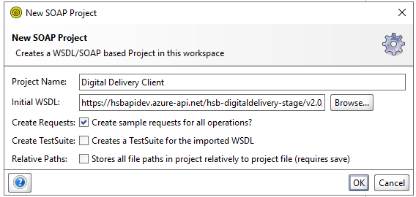

Click on request after successful project creation. Replace service url and sample request
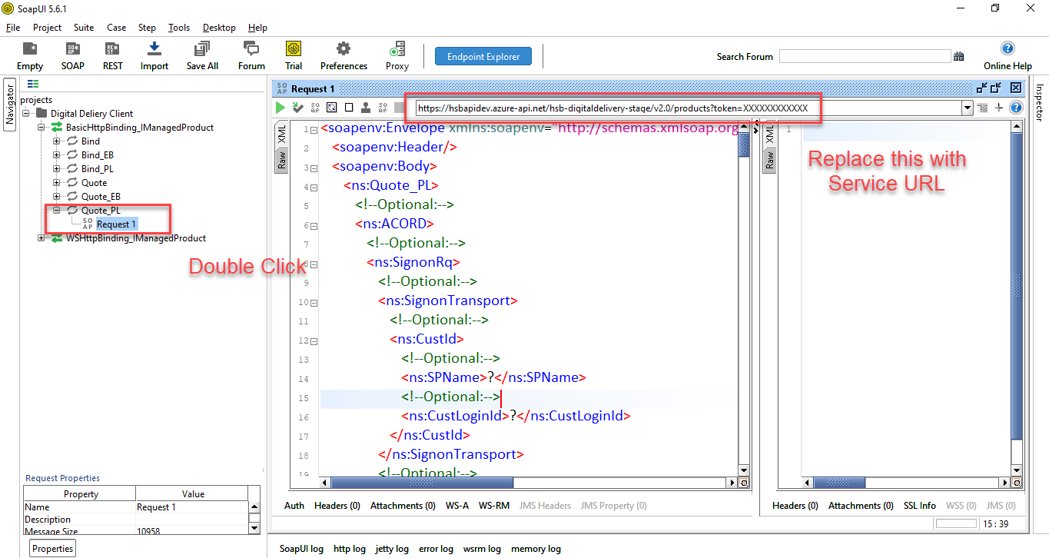
Below attachment for quote request and response.
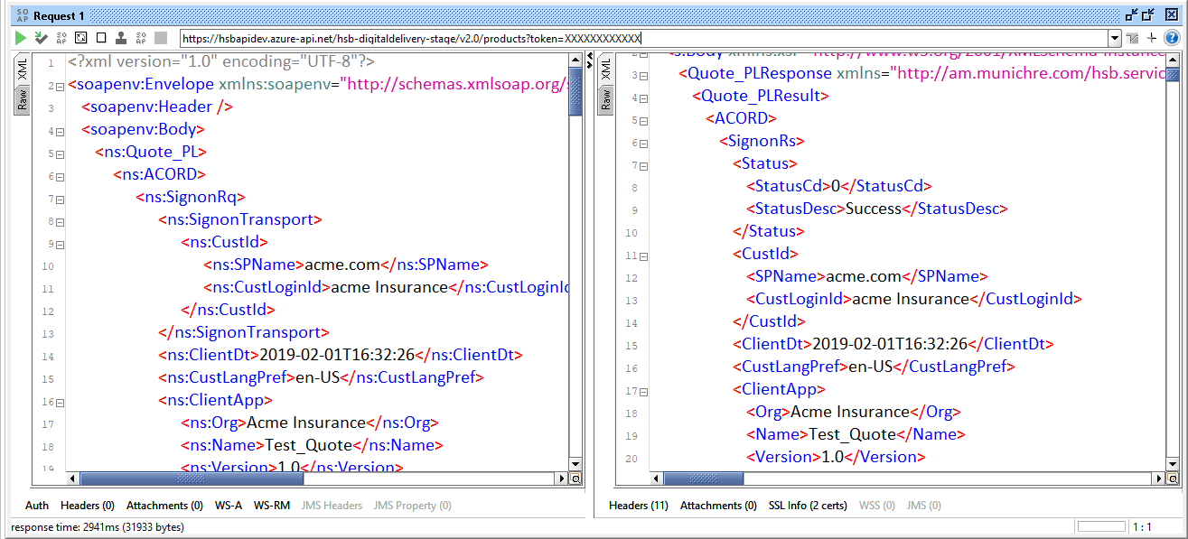

Below attachment for Bind request and response.
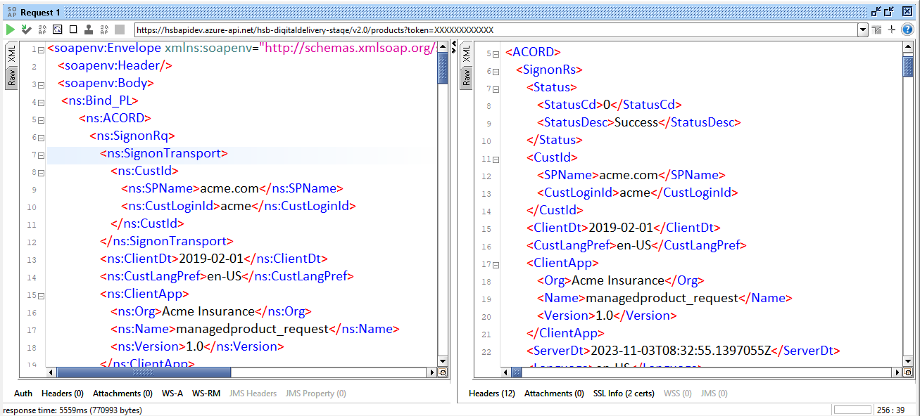

Below attachment for display FormData.
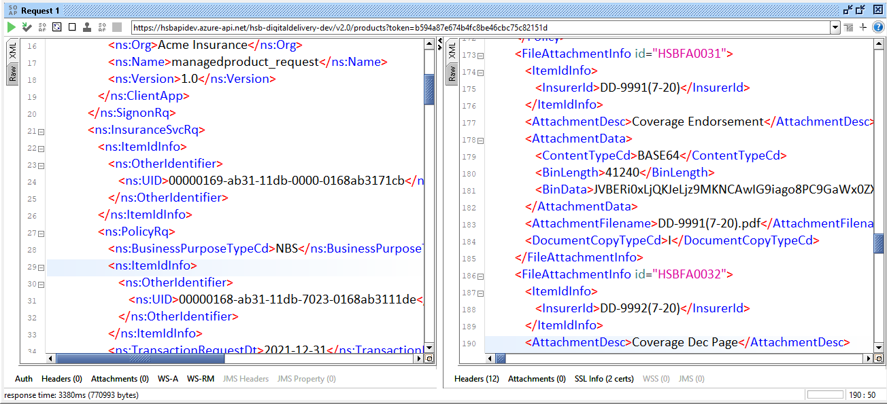

Document Revision History

Version | Date | Updated By | Revision Description
1.0 | 08-Dec-2021 | Shwetav Pandit | Initial Version
1.1 | 24-Mar-2023 | Ryan Griffin | Updated Branding and API Version
2.0 | 02-Nov-2023 | Shwetav Pandit | Updated per the new Updates
3.0 | 03-Nov-2023 | Prathamesh Chavan | Updated the How to Test Section with new updates and screenshots.  Added missing nodes in the Quote and Bind Section.
3.0 | 02-Jan-2024 | Ritik Rahangdale | Updated YearBuilt node as non-mandatory in Bind Request.
5.0 | 21-Mar-2024 | Shwetav Pandit | Quote –  - Added Location level details to support multiple dwelling addresses.  - Locations Ids are referred to Dwelling details  - Added Gross and Net premium at the location level for HSP and Service line  Bind –  - Removed HomeLineBusiness aggregate from Bind request and response.  - Moved the Deductible and Limit details from CoverageAvailable node to Coverage node for each product and removed the CoverageAvailable aggregate.
6.0 | 2-May-2024 | Shwetav Pandit | Added Reinstatement transaction on the Bind API, new error code HSBERR000006 in case of invalid request.  Need to check the Transaction request date on the REI, the TransactionRequestDt cannot be greater than X days from the TransactionEffectiveDt of the matching XLC transaction. X is the number of days in which cancelled policy can be reinstated.  Example - X = 3 | XLC - Transaction effective date = 4/18/2024 | REI Transaction request date = 4/21/2024, then Error. HSBERR000006 - Cancelled Policy cannot be reinstated.
7.0 | 9-Oct-2024 | Fran Zygmont | Added columns in Quote and Bind Requests to denote which fields are required from a reporting perspective (Bordereau and./or Inforce Files).
8.0 | 17-Oct-2024 | Shwetav Pandit | Added new error code HSBERR000007
9.0 | 8-Nov-2024 | Fran Zygmont | Added explanations and remediation steps for each error code.

